

**Advanced Software Engineering**

Course # CSEE 5551 0001

Semester: Spring 2017

LAB Assignment # 8

Submission Date: 3/15/2017

Student Name: Satya Sai Deepthi Katta

Student ID: 16231371

**Instructor:** Dr. Yugyung Lee

**Email:** LeeYu@umkc.edu

**Department of Computer Science & Electrical Engineering**

**University of Missouri, Kansas City**

**Welcome to Lab Assignment #8 Wiki Page!**

Submission on 3/15/17

**Abstract:**

The main objective of this assignment is to provide a plugin to Ionic FrameWork Application created in Lab Assignment 7. The application is located to extract nearby restaurants from a particular location. Now using Google Co-ordinates are implemented by adding the Co-ordinates Cordova Plugin in the Ionic Frame Work Application. Then the application is deployed to the android device. Yslow is used to test the performance of all the web pages created.

**TASK1: Use at least one Cordova Plugin related to your project**

An Ionic Framework Application is created using Brackets Software. A basic login page consisting of Login and Register buttons. On clicking Login, the application is navigated to home page. On clicking Register, the application opens a register page which takes the details of a new user.

**A user account is created for ‘Admin’. The username and password are set inbuilt in the application as “Admin”. On clicking Create Account, a new account is created.**

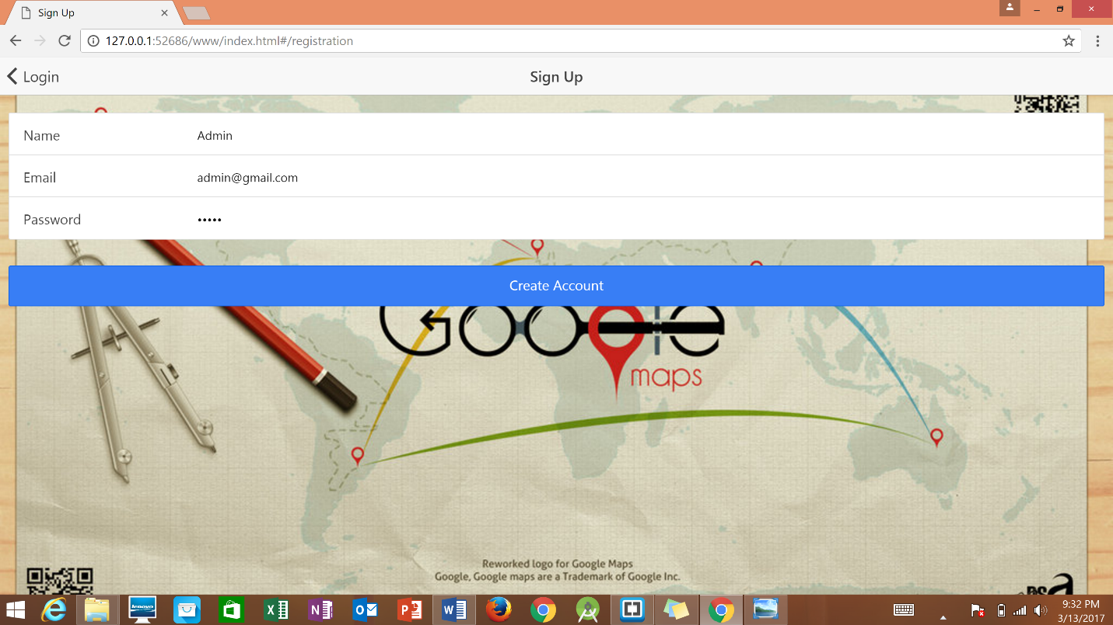

**Fig 1. Admin registration in the Web Application.**

Entering the correct credentials, login will move to home page. If credentials are incorrect then a error message pops up showing ‘Invalid Credentials’.

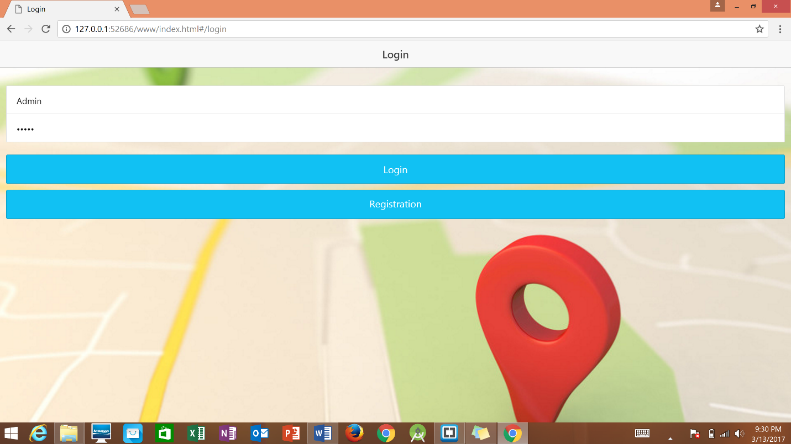

Fig 2. User Login into Web Application using Admin Credentials.

In case of the failure, Login Credential check pops up.

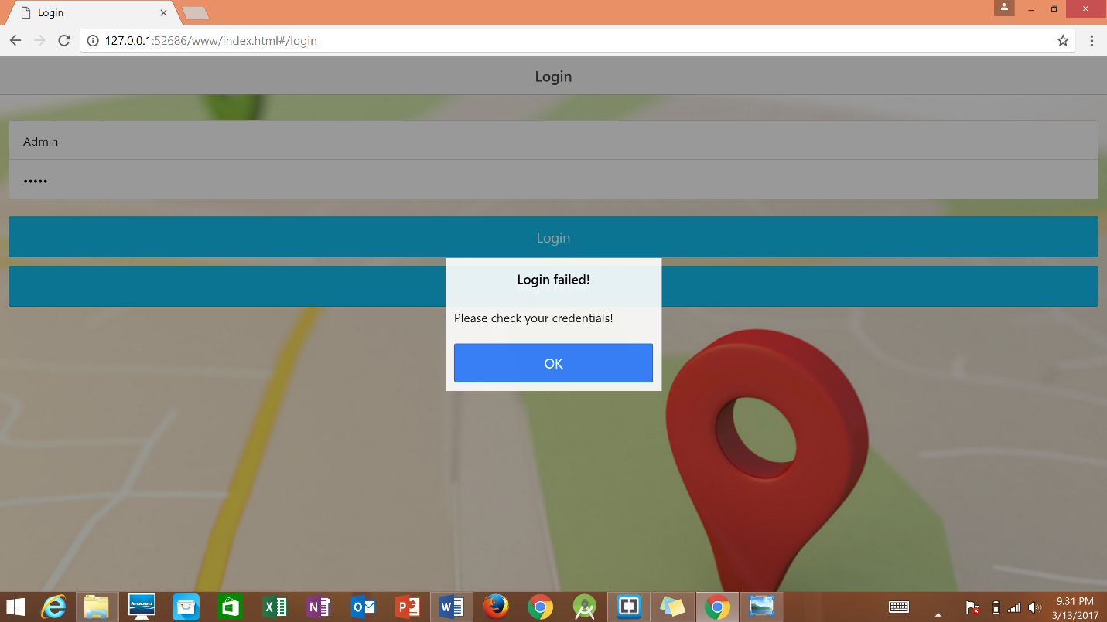

Fig 3. Invalid Credentials check pops up.

After successful login into the account, the web page navigates to the Geo location where a button is provided to Get Current Location Co-ordinates.

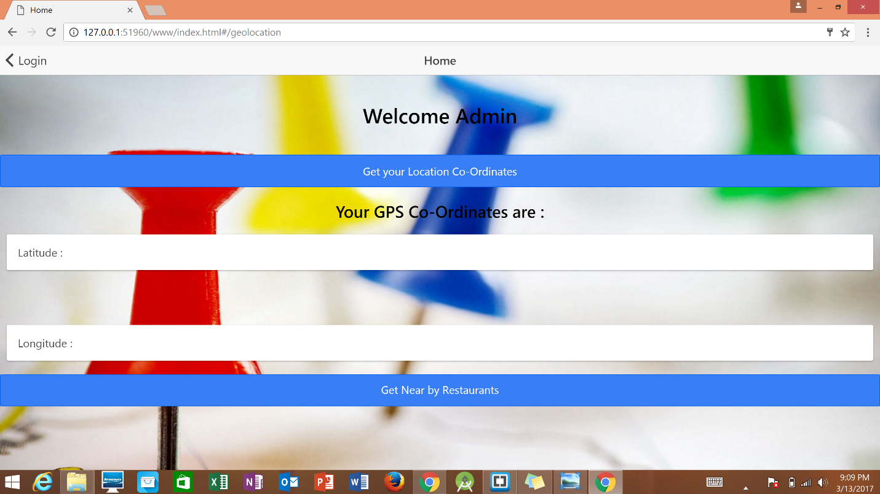

Fig 4. Navigating to Geo Location Page from Login Page.

Now the browser asks for the permission to turn on the location services. By allowing location services, the current location coordinates are tracked using the Cordova plugin implemented in the application. Google Maps API track the location address by which location coordinates are displayed on the screen.

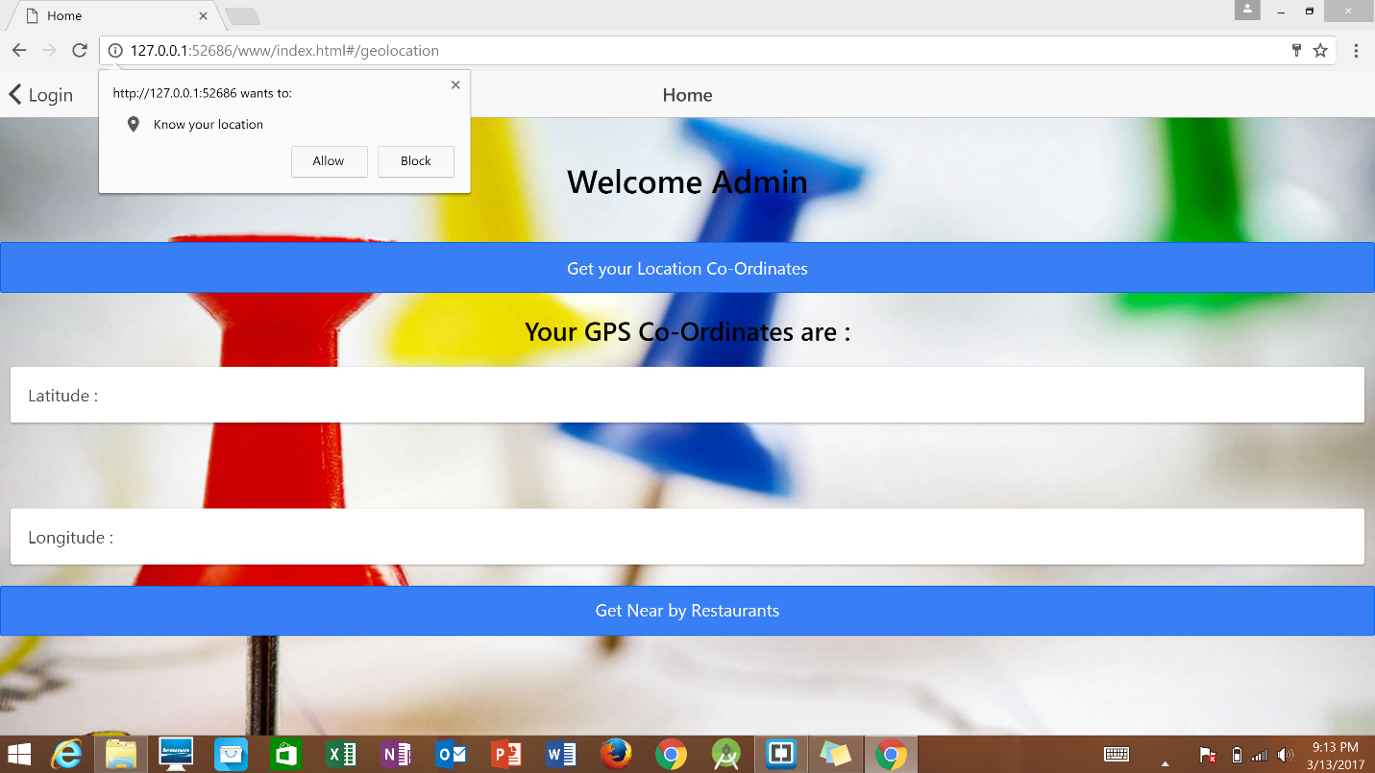

Fig 5. Permission to know current location of the User.

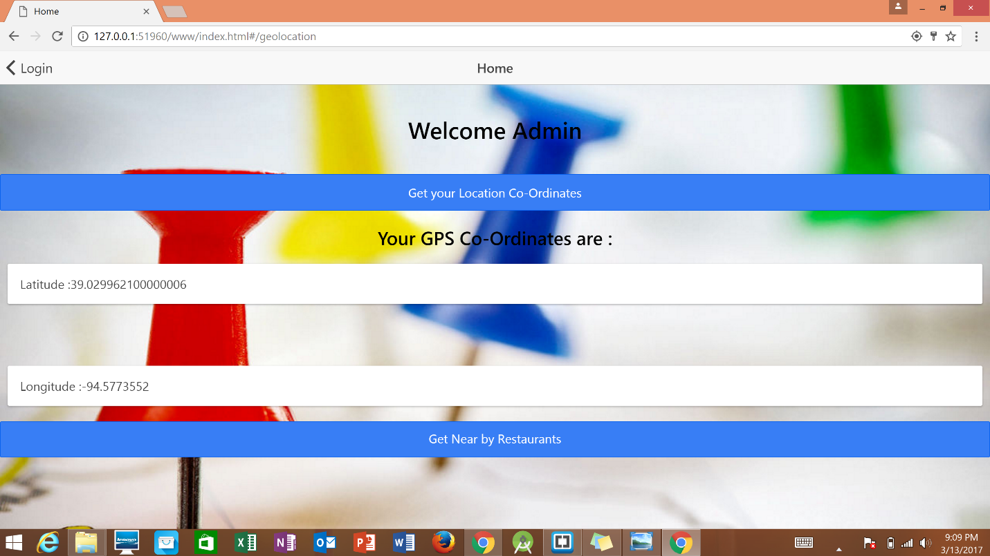

Fig 6. Displaying Location Co-ordinates of the User.

When the user clicks on ‘Get Near By Restaurants’, the application navigates to the list of restaurants nearby sorted according to the nearest distance first. The details of the restaurants like restaurant name and the distance from the current location are also given in the list.

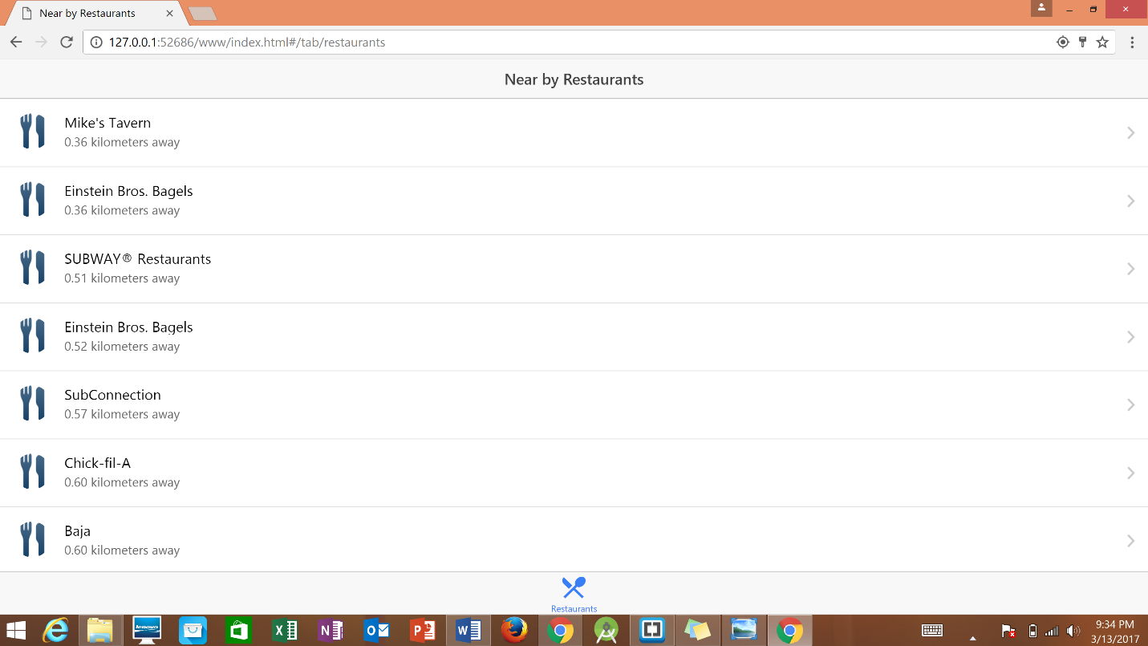

**Fig 7. List of Near By Restaurants displayed through Web Application.**

**On selecting a restaurant, further details of the restaurant like Address with postal code, phone number are displayed. Along with these, two options are displayed. ‘View photos’ shows the pictures of the food in the restaurant. By selecting ‘Get Directions’ gets the directions from the current location to the restaurant using Google Maps API.**

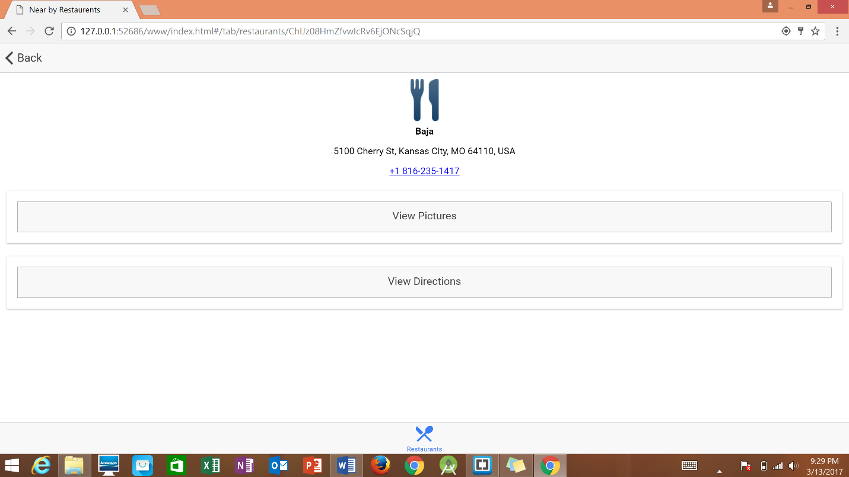

**Fig 8. Details of the selected restaurant from the List of nearby restaurants.**

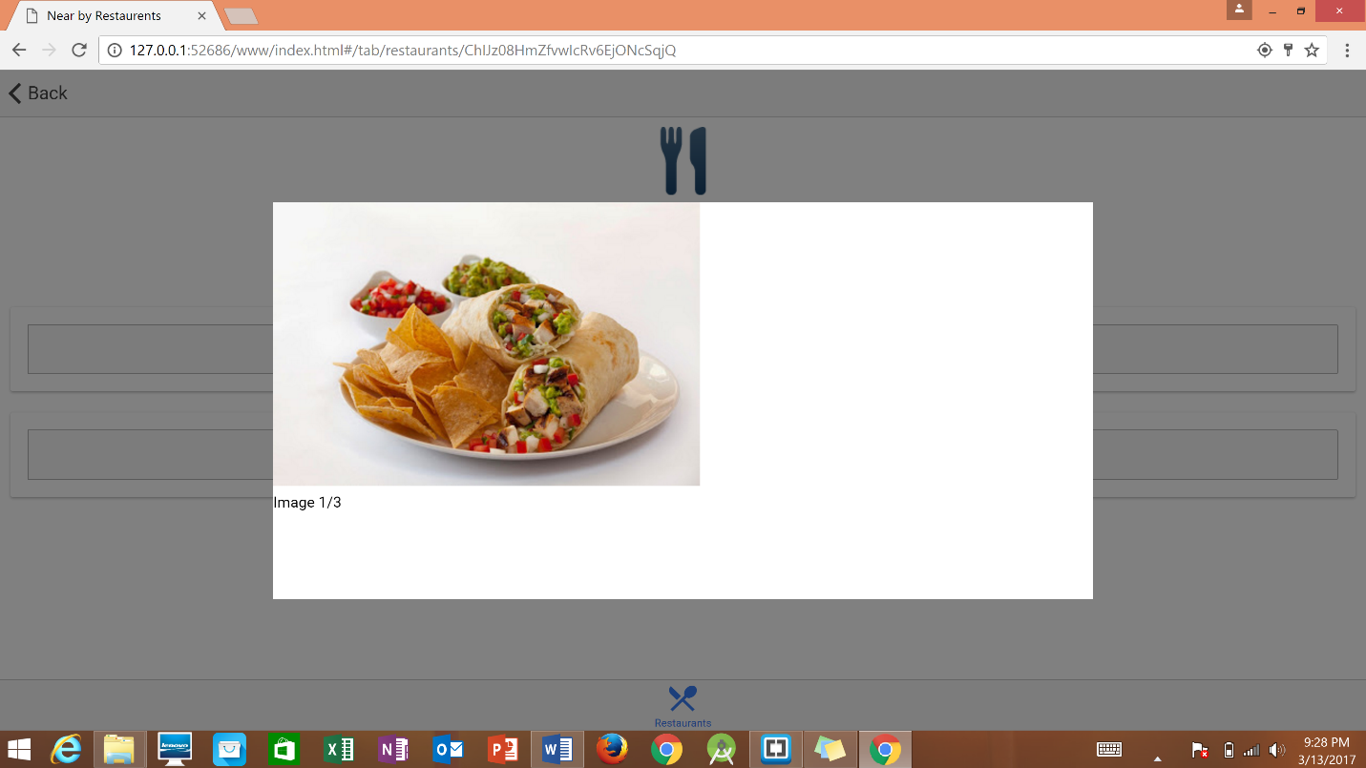

**Fig 9. Displaying photos of food from the restaurant.**

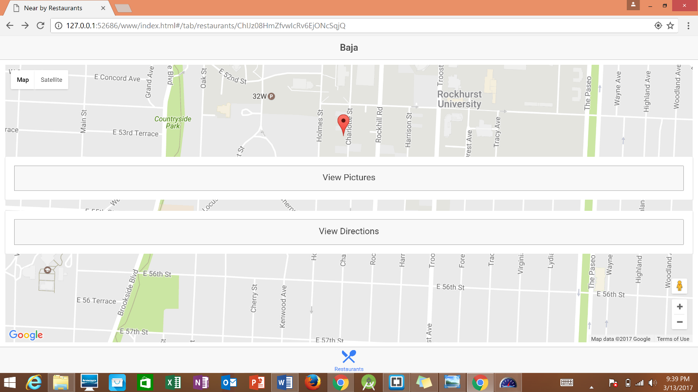

**Fig 10. Locating the current location in the map.**

**TASK 2: Use Yslow to Analyse the Performance of all HTML Pages.**

The performance analysis of all HTML pages are done using YSlow Testing Tool. The screenshots are provided below with the grades given to all the HTML pages.

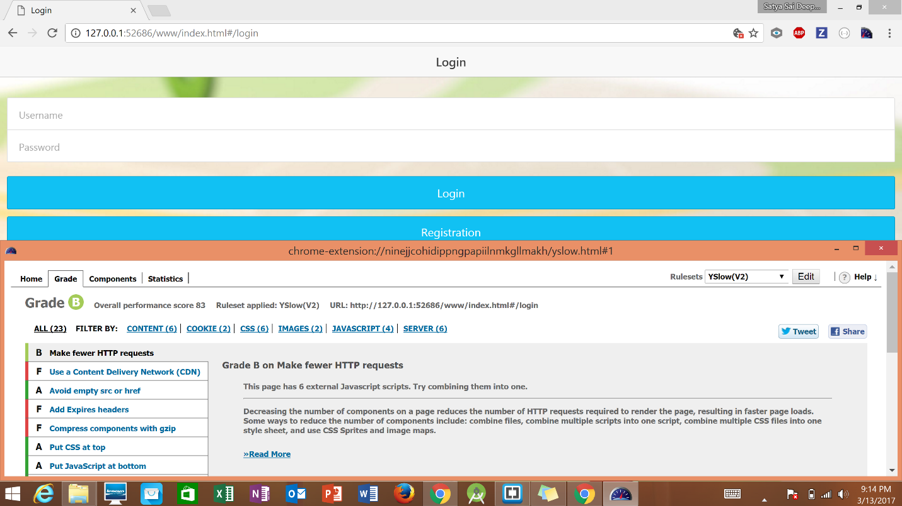

Fig 11. YSlow analysis for Login Page.

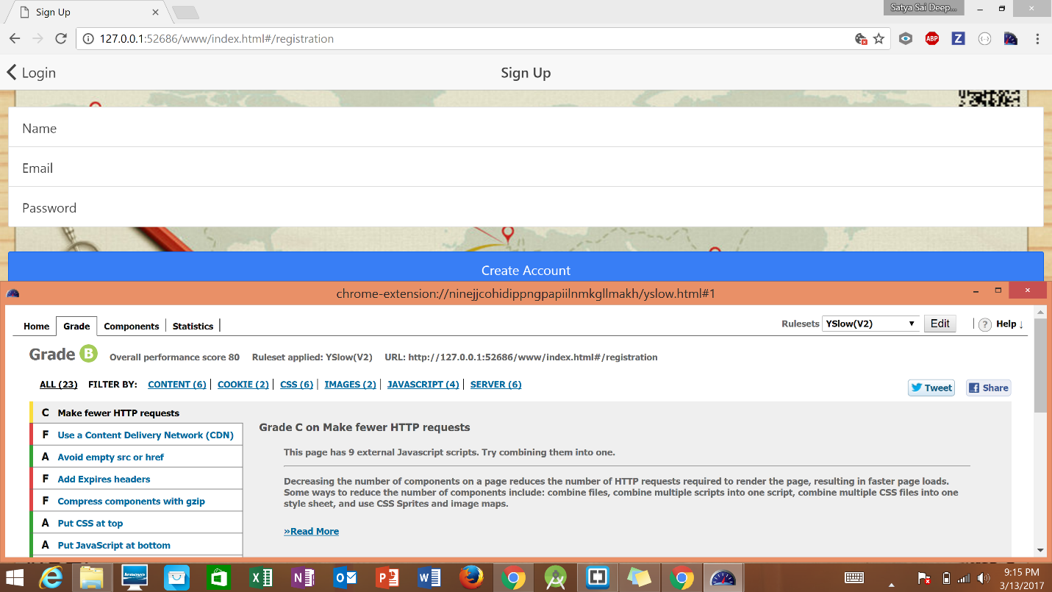

Fig 12. YSlow Analysis for Registration Page.

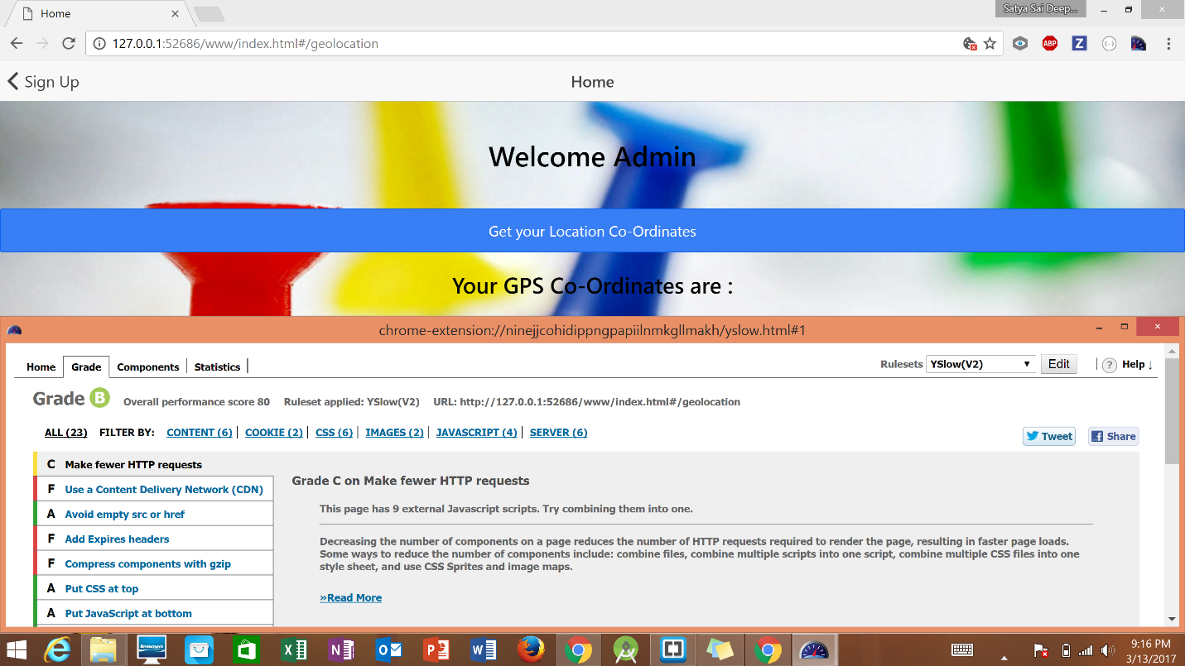

Fig 13. YSlow Analysis for Geo Location Page.

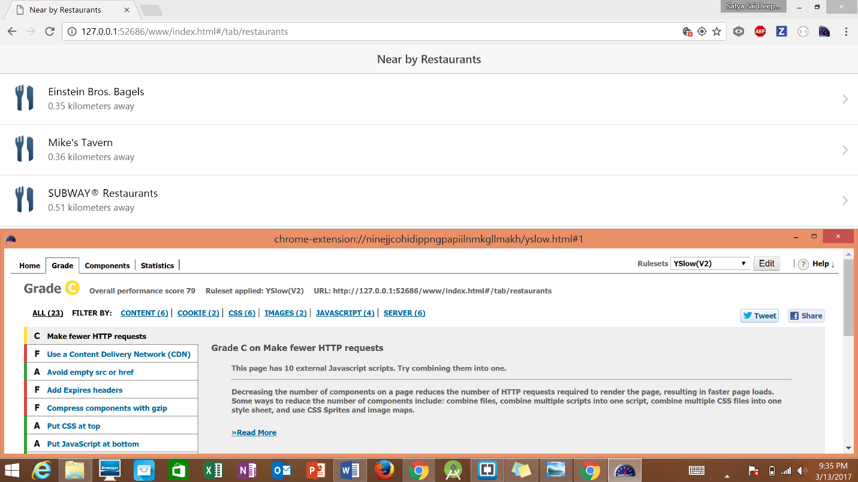

Fig 14. Yslow Performance Analysis for List of Restaurants Page.

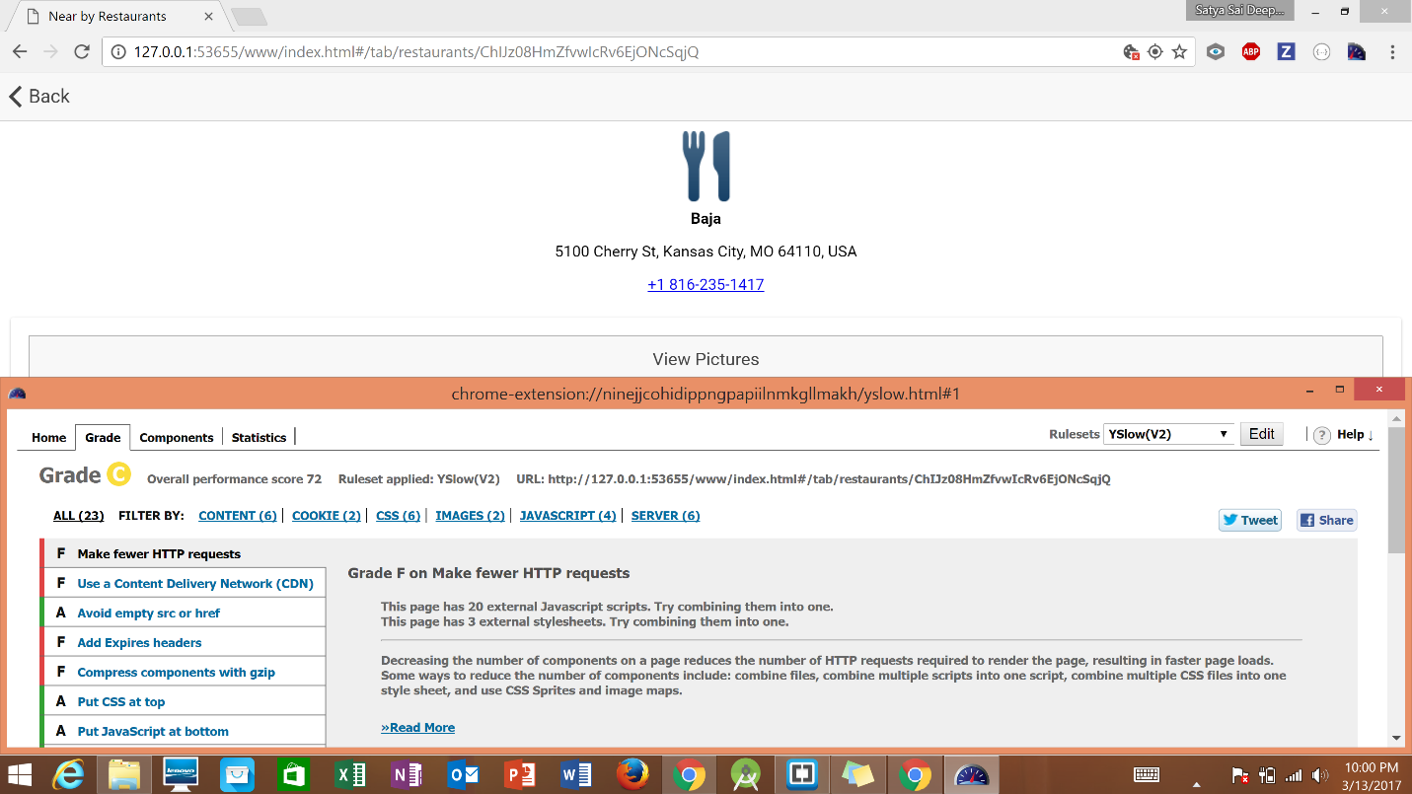

Fig 15. YSlow Analysis for Restaurant Details Page.

In addition to Yslow, performance analysis is done on the web application through Selenium IDE Tool by running the application in Mozilla Firefox browser.

The screenshot is provided below for the obtained test results.

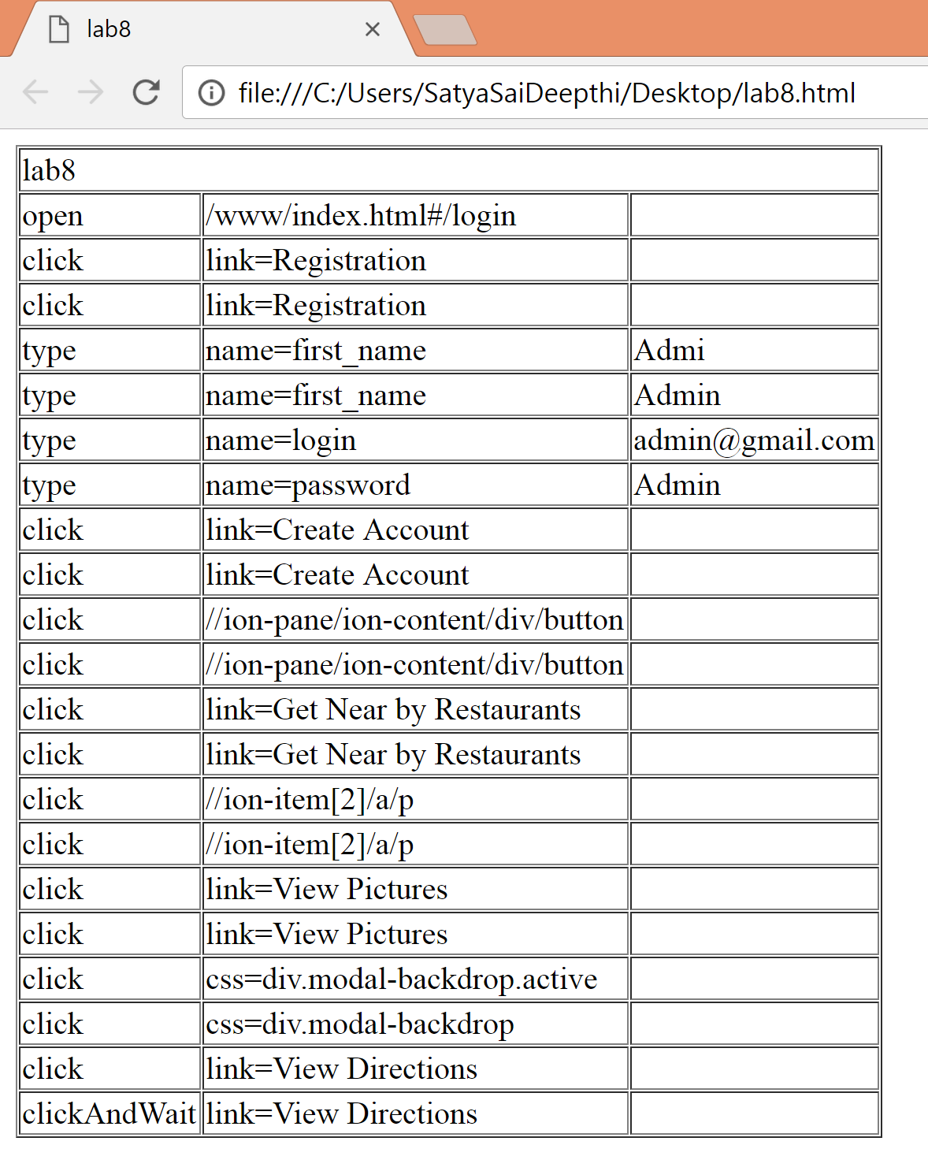

Fig 16. Selenium IDE Testing results for the Ionic Application.

**TASK 3: Deploy application to Android Device.**

**Mobile Application is created for the Ionic Framework Application. The screenshots are given below for the mobile application which is run on an android emulator.**

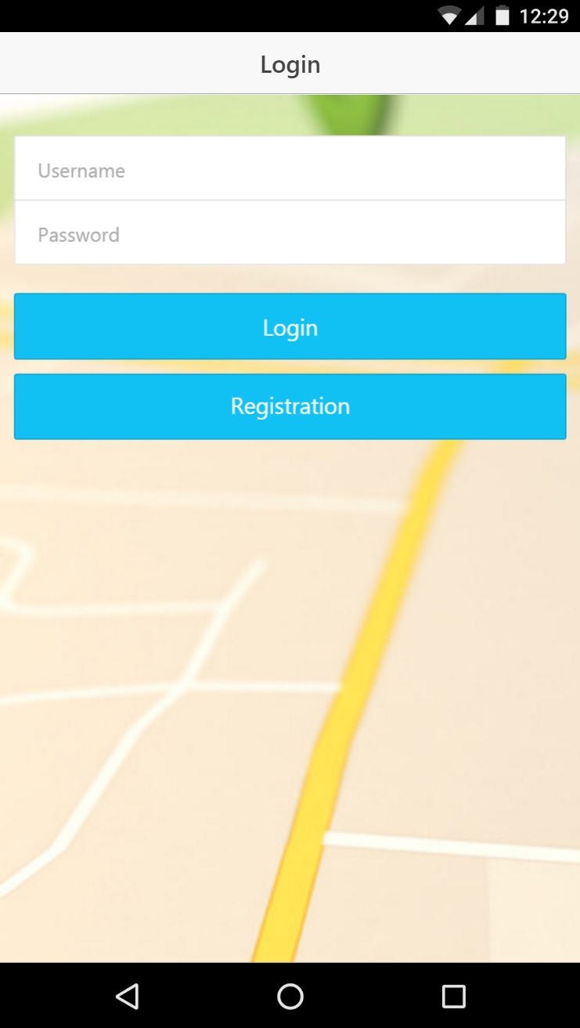

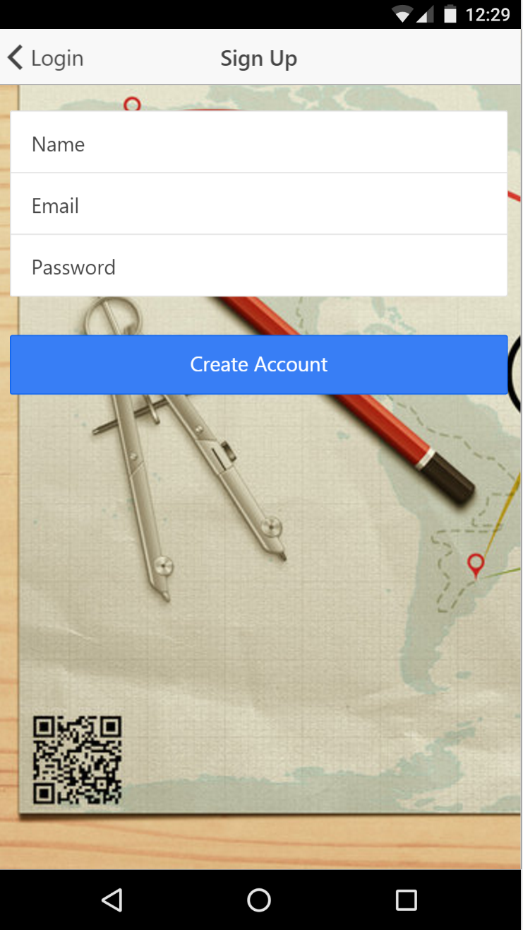

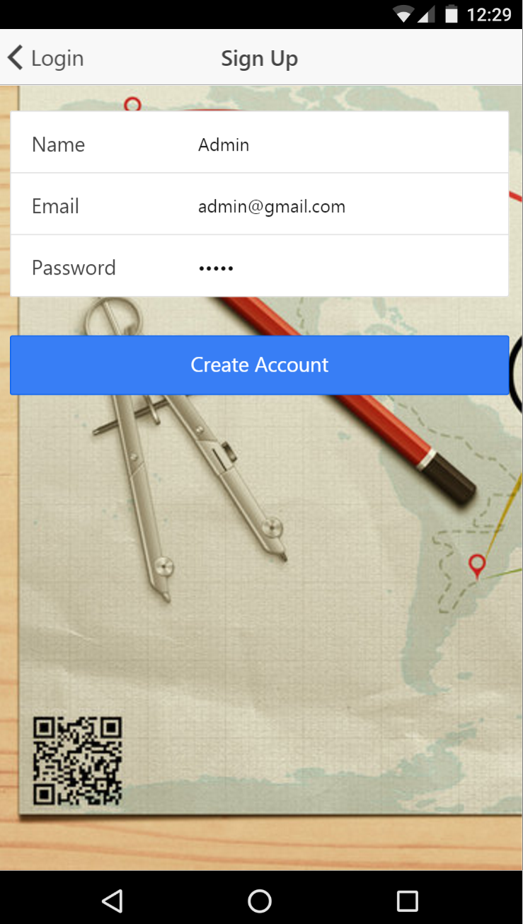

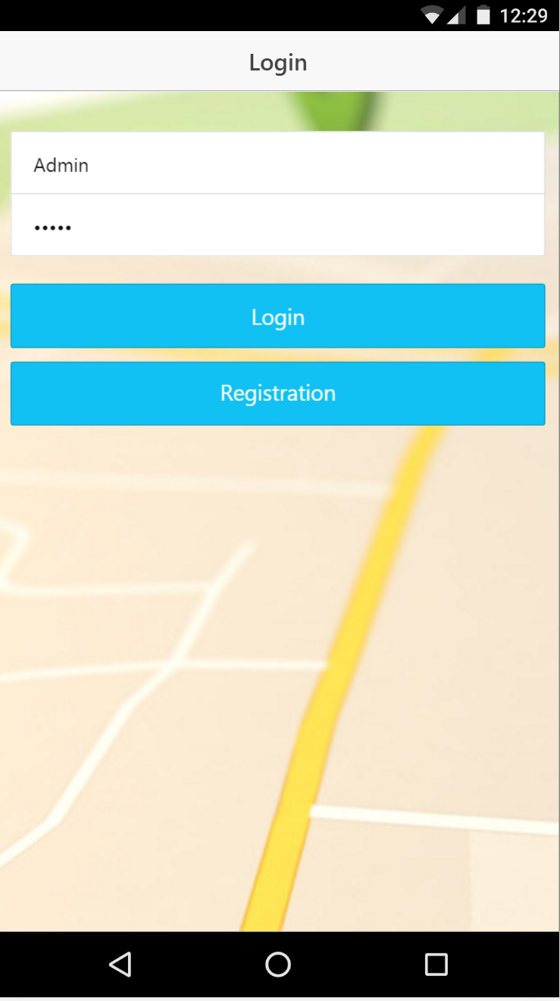

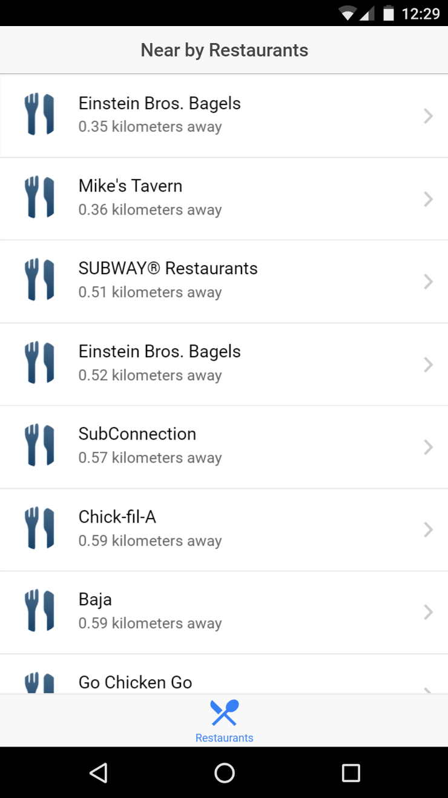

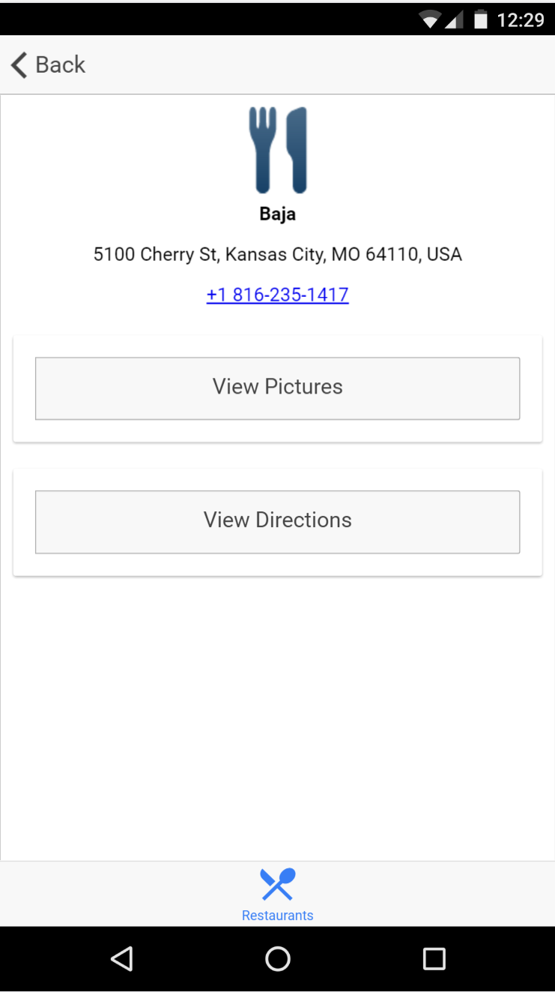

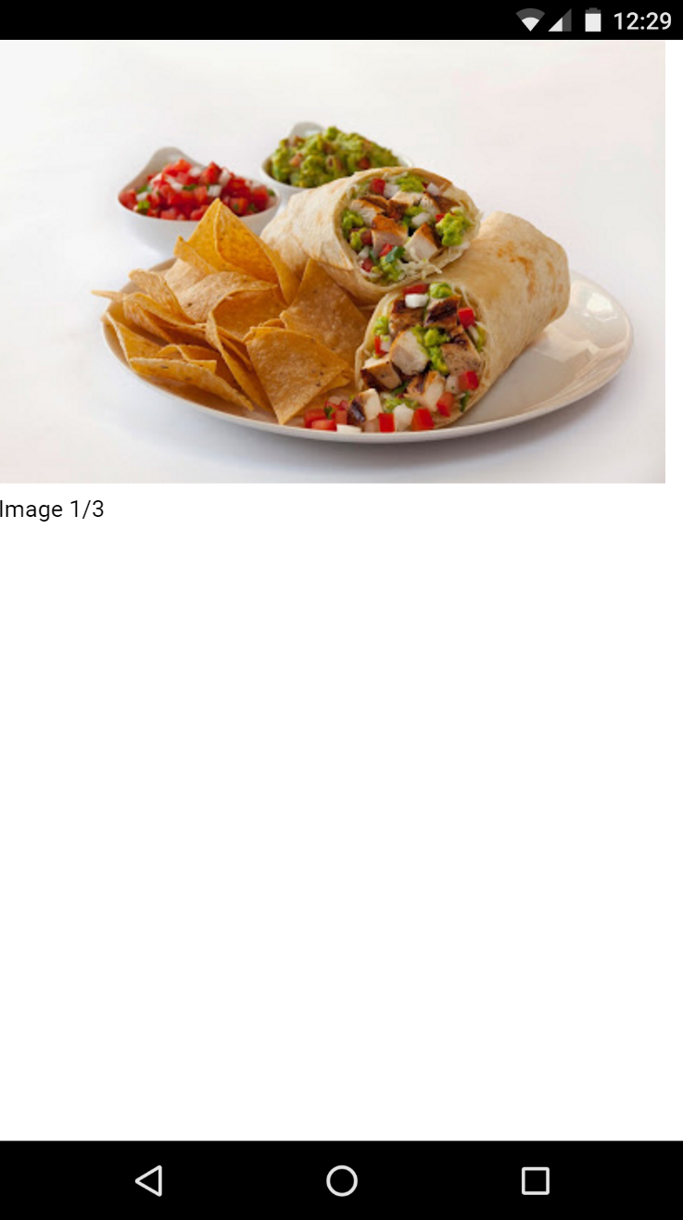

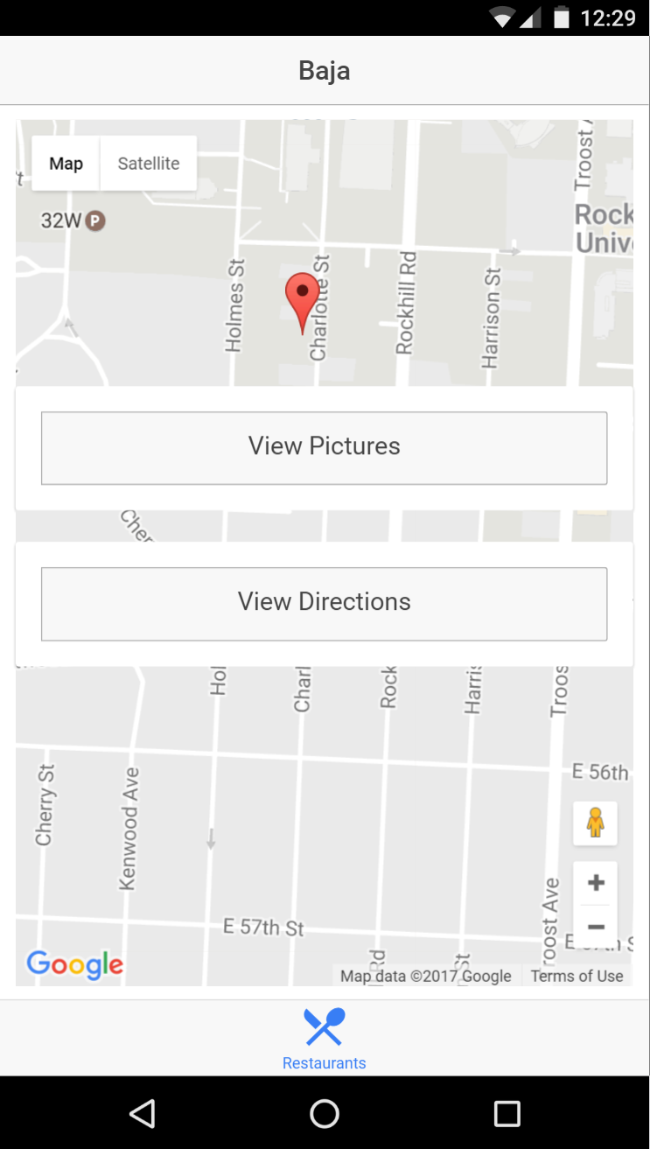

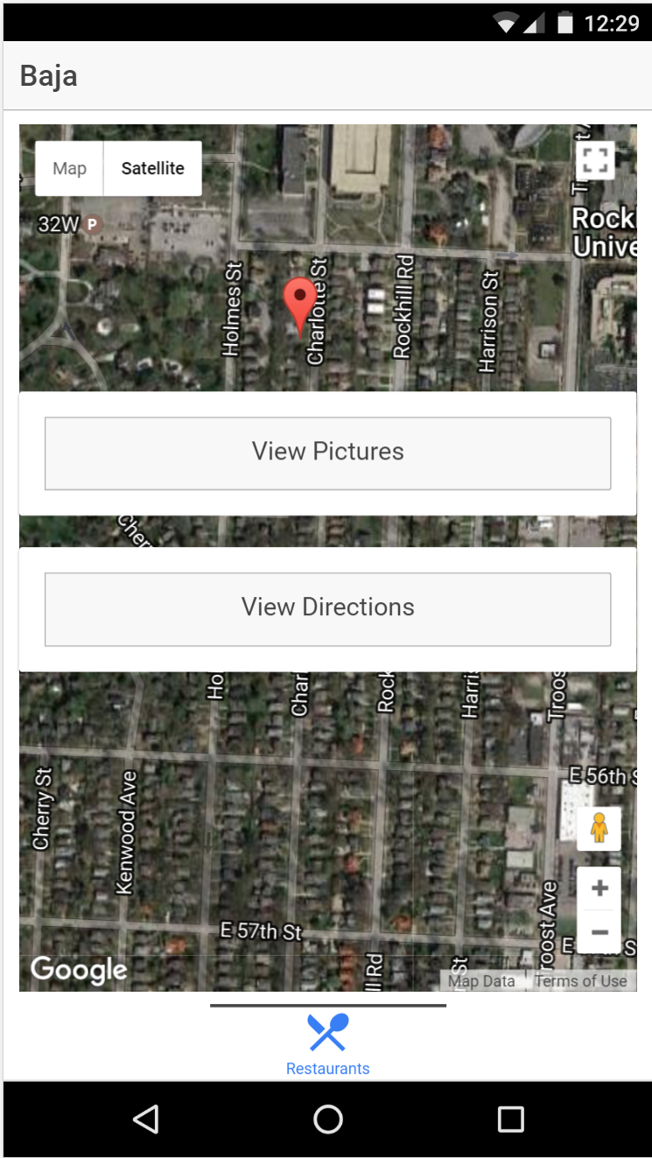

**References:**

<https://developers.google.com/maps/documentation/business/>

<http://ionicframework.com/docs/>

<https://developers.google.com/places/>

<https://developers.google.com/maps/>